**[14] Design PDA For Input AABBBBC ( L = AnB2n )**

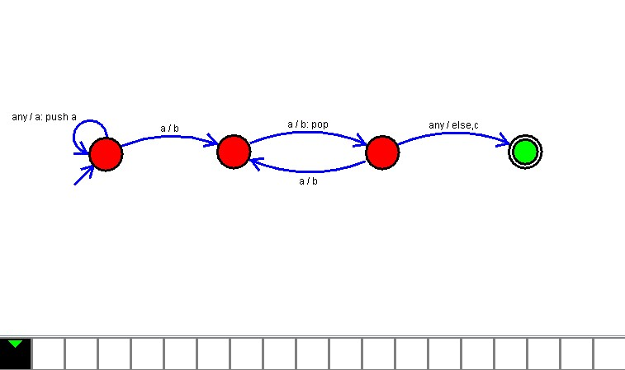

**Result**

The PDA is designed to compute the given strings as input using AutoSim tool